Lesson 5 Demo 17: Using Templates

This section will guide you to:

* Demonstrate the use of templates in Docker

**Step 1:** Set the template of the created containers based on the service’s name, node’s ID, and the hostname

*sudo docker service create *

*--name hosttempl *

*--hostname="{{.Node.Hostname}}-{{.Node.ID}}-{{.Service.Name}}" *

*busybox top*

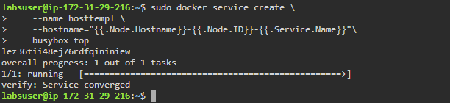

**Step 2:** Show the status of all the running tasks of the service *hosttemp1*

*sudo docker service ps hosttempl*



**Step 3:** Use the following command to inspect the *hosttempl* service

*sudo docker inspect SERVICE_ID --format "{{json .Status}}"*

*Note: Replace SERVICE_ID with the ID of the* ***hosttempl*** *service*

